

Bihi Towers 9th Floor, Room 5 Moi Avenue

P.O. Box 35351 – 00100, Nairobi, Kenya

TRIMLINE SYSTEMS & SOLUTIONS

Tel: 0710563359

Email: trimlinesys@gmail.com

# PRODUCT DESCRIPTION

# TrimFarm System

Contents

PRODUCT DESCRIPTION 1

TrimFarm System 1

Description 2

Agricultural marketing societies. 2

Consumer cooperative 2

Savings and credit cooperative. 2

The processing cooperative. 3

Transport cooperative. 3

Insurance cooperative. 3

Housing corporative. 3

Features 3

Members Management 3

Collection 4

Credit management 6

Inventory management 6

Payout 7

Sales and marketing 8

Finance and cash management 8

Manufacturing 9

Warehouse 10

Security 10

Web services 10

Encryption 10

Passwords 10

User rights 10

Pricing 11

Project Plan 11



## Description

A cooperative society is a group of individuals who have specific common needs. It is an economic enterprise, the purpose of which is to improve the economic status of owners or members. Most cooperative societies offer their products to their members and others do not serve non-members.  
Cooperative societies have varied classification depending on what their members are concerned with. They include:

### Agricultural marketing societies.

They are cooperative in the Agricultural and marketing sector. Their functions are to collect, process, store and save members' produce. These cooperative play a major role as some small scale farmers would have a hard time marketing their products individually.

### Consumer cooperative

They are generally formed to meet and supply members' demand for food, clothing and general household goods. This aim is fulfilled through members running consumer shops and wholesale facilities where members buy goods at lower prices compared to those in the market. They were prominent in the sixties and contributed to the origin of supermarkets.

### Savings and credit cooperative.

They are the more common type found in Kenya. Their main purpose is to mobilize savings and channel them to individual members as loans for specific development projects at affordable rates of interest.

### Processing cooperative.

They have a similarity to agricultural and marketing. Their main function however is to process the products for members. An example is the Kenya cooperative creameries.

### Transport cooperative.

They are involved in purchasing vehicles and using them for public transport or for hiring or leasing.  
They may also be formed for management of public transport vehicles of their members.

### Insurance cooperative.

They have the project of developing and providing insurance services based on the cooperative principles. They also provide insurance covers to cooperative societies.

### Housing corporative.

They buy and develop houses for the members or sell houses to members at lower prices.

## Features

*TrimFarm* is customizes with all these sectors in mind, below is a number of customized modules.

### Members Management

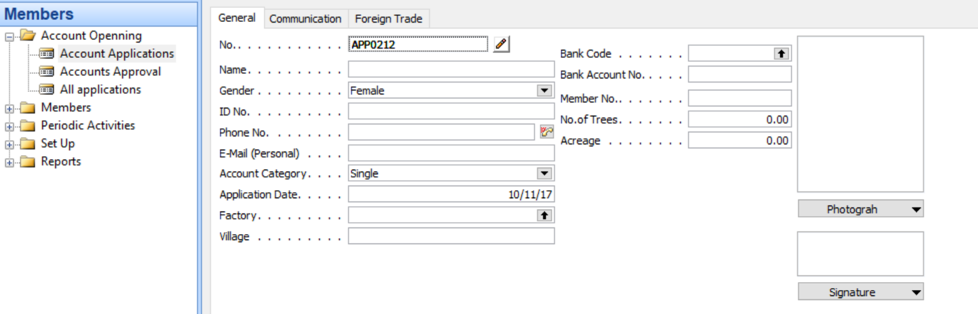

Members/farmers registration is done in this module. All key details of members/Farmers is keyed in here. After application the new account undergoes approval for it to be fully active in the system. Active accounts are open for credits and also hold members/farmers key financial information like account balances, credit balances etc. 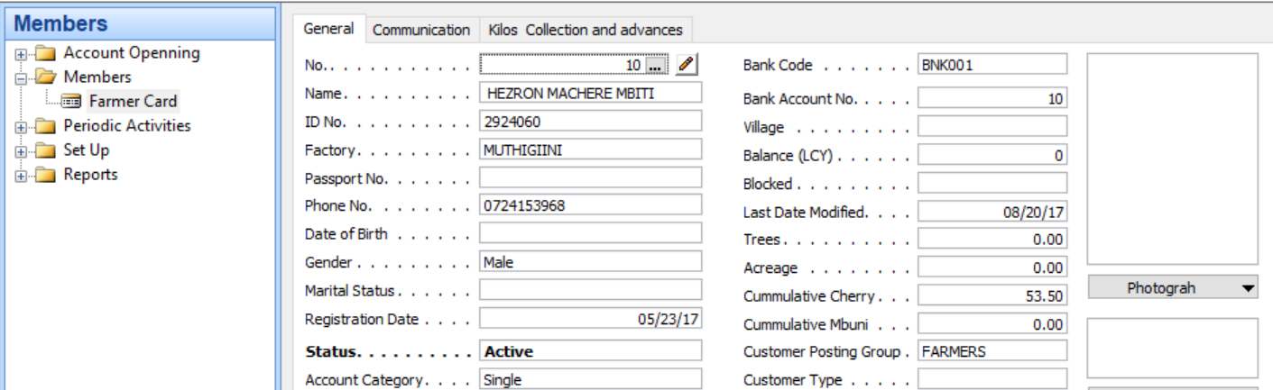

### Collection

Produce collection is a key element of the society operations, this is where farmers produce is weighed and the relevant gross and net weights attached to the farmer’s collection list.

Our Trimfarm system is well customized for this purpose, we have digital scales that are connected to the system by either Bluetooth or serial connection. The exact weigh reflected to the collection application, other relevant information is keyed in, ie no of bags. For the net weight calculation. Note that the gross weight is captured from the scale and **not** entered manually.

Once the relevant details are captured a receipt is generated for the Farmer/Member for future reference. On some of our clients we have gone further and incorporated sms messaging and farmers are notified of their produce and the cumulative.

On data collected in remote areas, we have a stress free connection to the Cooperative’s head office servers where all data collected is sent to the server in real time.

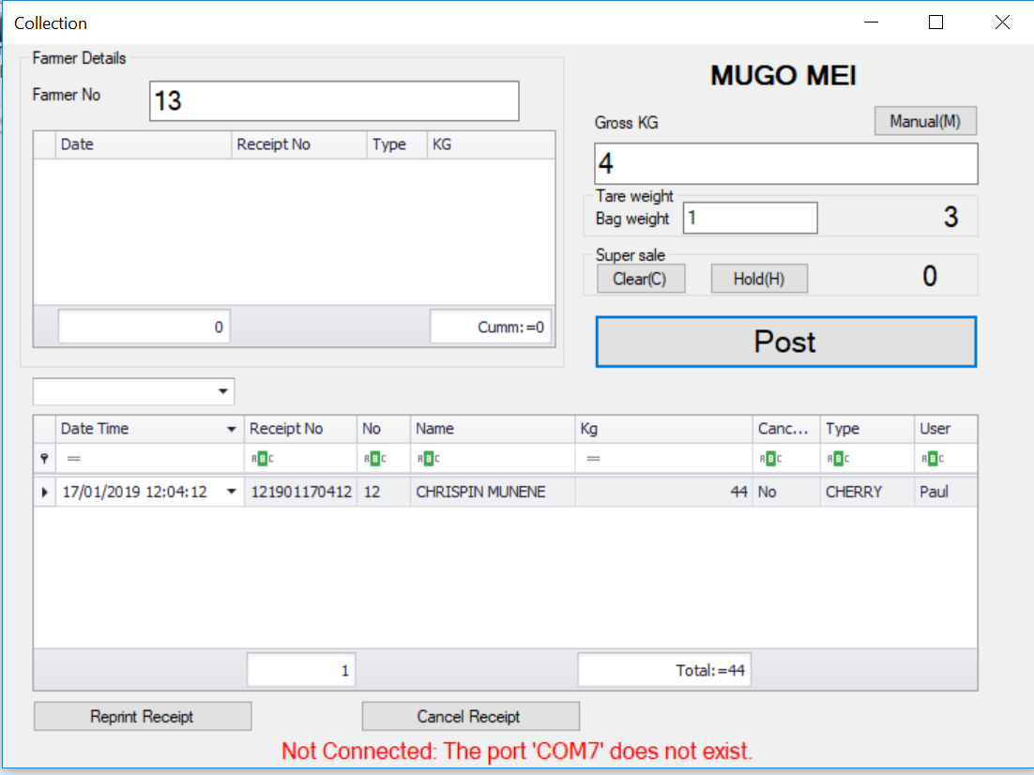 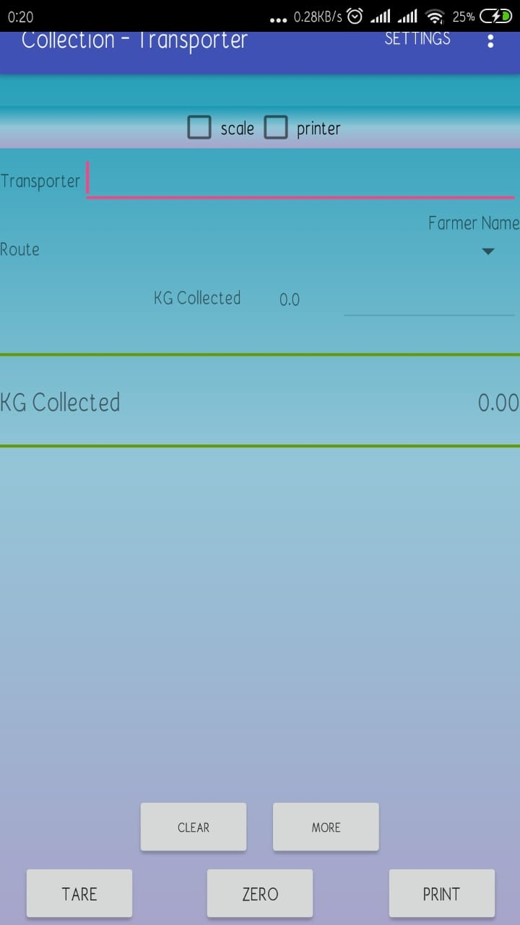

*Desktop application* *Mobile Application*

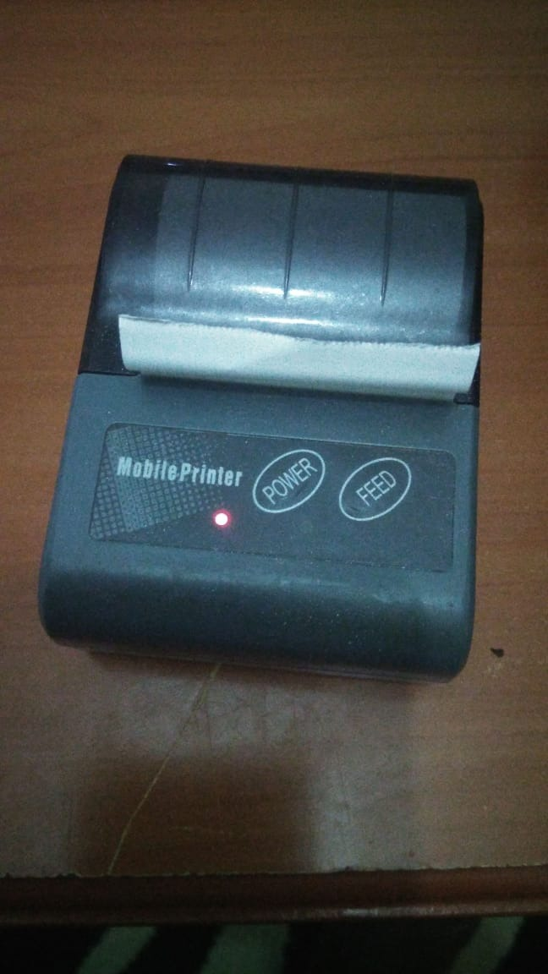

*Mobile printer(Bluetooth)*

*Back end module*

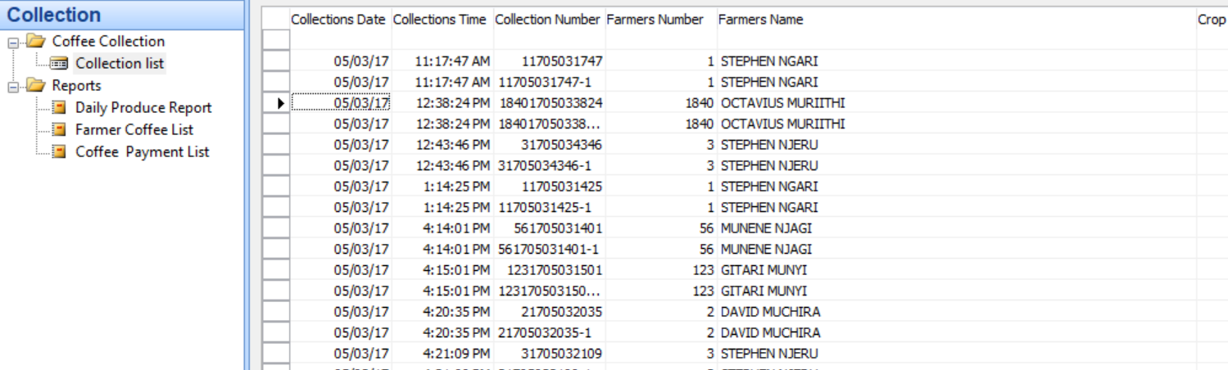

### Credit management

All advances and credits are managed in this module, interests are also set in this module.

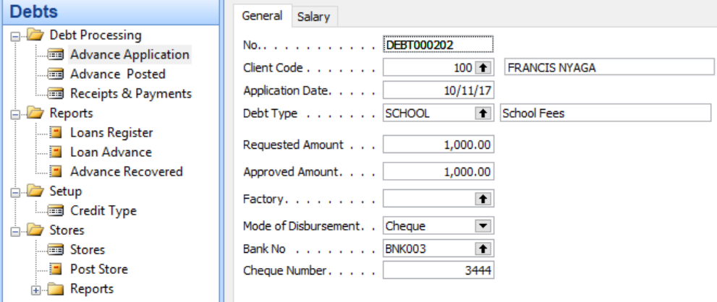

### Inventory management

Inventory items i.e. farmers produce, inputs, and manufactured products are managed in this module. It also manages the selling price, buying prices, inventory balances, reorder level, suppliers etc.

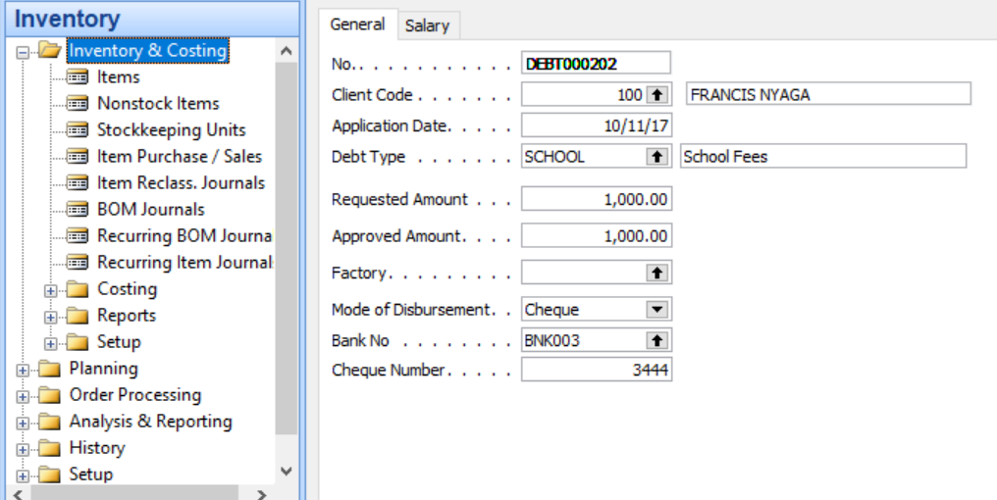

### Payout

Farmers are paid their produce on this module. Appropriate payment rates are set here, and credits arrears are deducted to get the net pay.

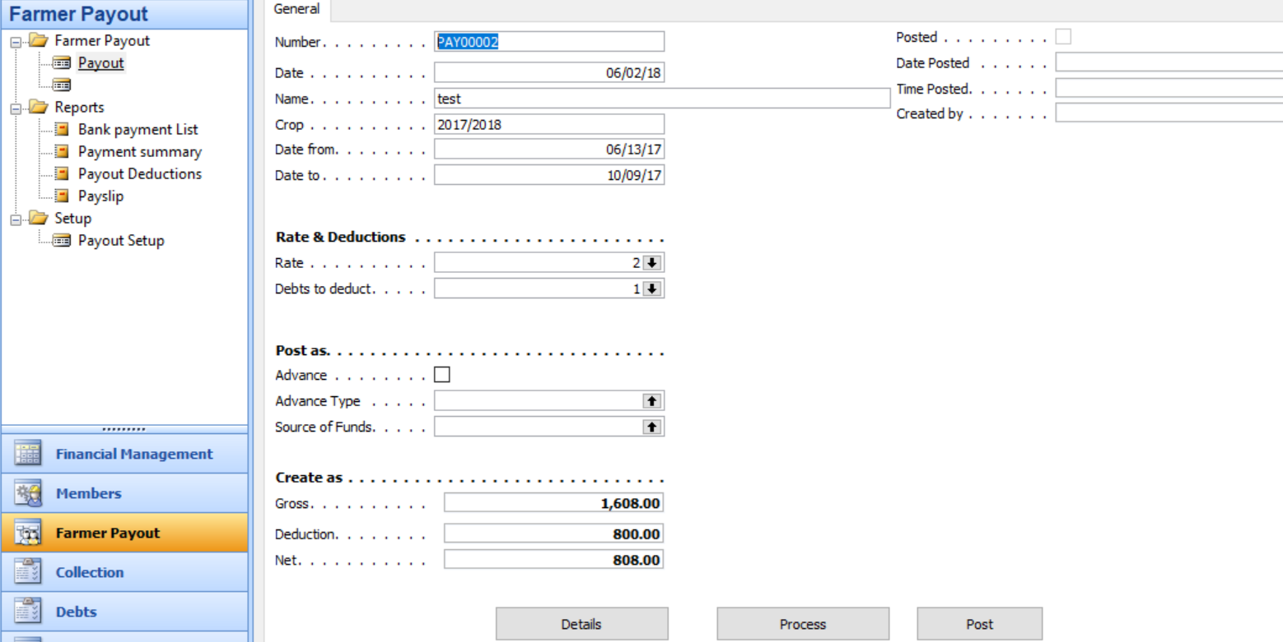

### Sales and marketing

This is an important question, because a carefully crafted combination of sales and marketing is vital for successful business growth. "Selling" or making sales consists of interpersonal interaction-the one-on-one meetings, telephone calls and networking-that you engage in with prospects and customers. The term "marketing" encompasses programs businesses use to reach and persuade prospects, including advertising, public relations, direct mail and more. You'll often see the terms used incorrectly, such as when a business advertises for a marketing professional but is really looking for someone to make telephone calls, meet with prospects and close sales.

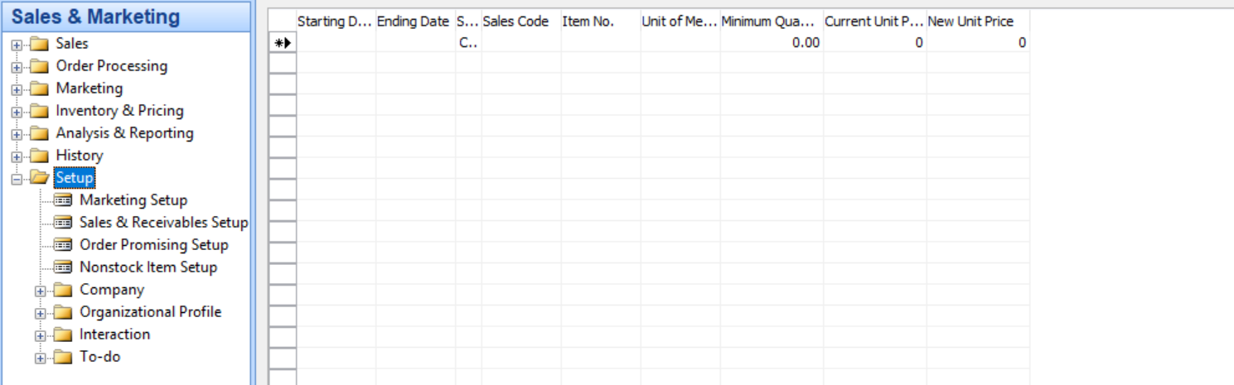

### Finance and cash management

All transactions be it in members account, inventory, petty cash, payment vouchers, cash receipts, sales are posted to finance module.

This in turn produces all financial reports, some of the submodules consist:

* Chart of accounts
* Budgets
* Journals
* Cash management
* Bank accounts
* Dimensions
* Receipts
* Payments
* Payables
* Receivables

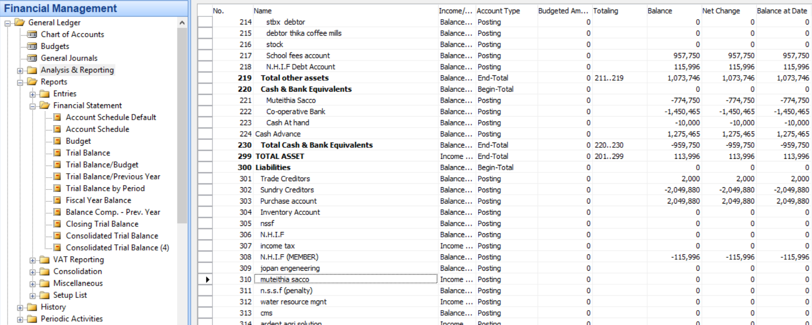

### Manufacturing

Manufacturing is the production of [merchandise](https://en.wikipedia.org/wiki/Merchandise) for use or sale using labour and [machines](https://en.wikipedia.org/wiki/Machine), [tools](https://en.wikipedia.org/wiki/Tool), chemical and [biological](https://en.wikipedia.org/wiki/Biological) processing, or formulation. The term may refer to a range of human activity, from [handicraft](https://en.wikipedia.org/wiki/Handicraft) to [high tech](https://en.wikipedia.org/wiki/High_tech_manufacturing), but is most commonly applied to [industrial](https://en.wikipedia.org/wiki/Industry) design , in which [raw materials](https://en.wikipedia.org/wiki/Raw_material) are transformed into [finished goods](https://en.wikipedia.org/wiki/Finished_good) on a large scale. Such finished goods may be sold to other manufacturers for the production of other, more complex products sold to [wholesalers](https://en.wikipedia.org/wiki/Wholesale), who in turn sell them to [retailers](https://en.wikipedia.org/wiki/Retailer), who then sell them to [end users](https://en.wikipedia.org/wiki/End_user) and [consumers](https://en.wikipedia.org/wiki/Consumer).

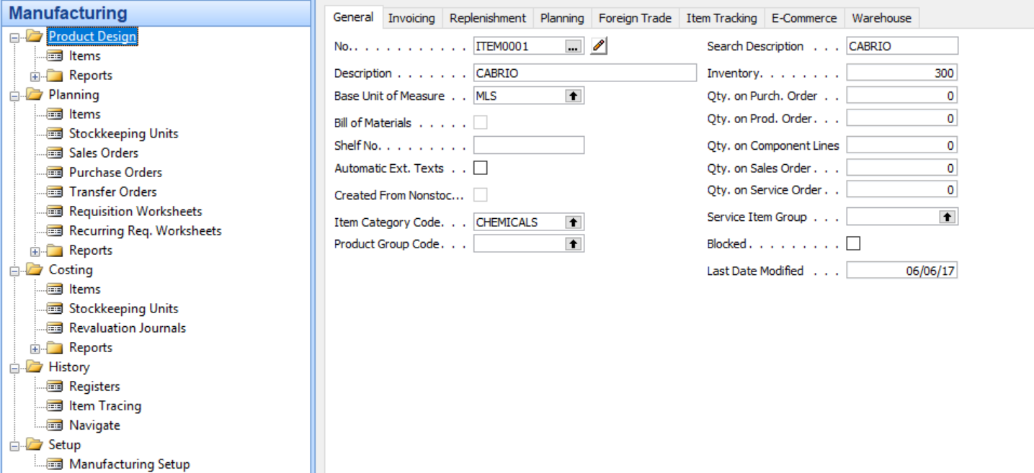

### Warehouse

A warehouse is a building for storing [goods](https://en.wikipedia.org/wiki/Good_(economics)). Warehouses are used by [manufacturers](https://en.wikipedia.org/wiki/Manufacturer), [importers](https://en.wikipedia.org/wiki/Importer), [exporters](https://en.wikipedia.org/wiki/Exporter), [wholesalers](https://en.wikipedia.org/wiki/Wholesaler), [transport](https://en.wikipedia.org/wiki/Transport) businesses, [customs](https://en.wikipedia.org/wiki/Customs), etc. They are usually large plain buildings in [industrial parks](https://en.wikipedia.org/wiki/Industrial_park) on the outskirts of cities, towns or villages.

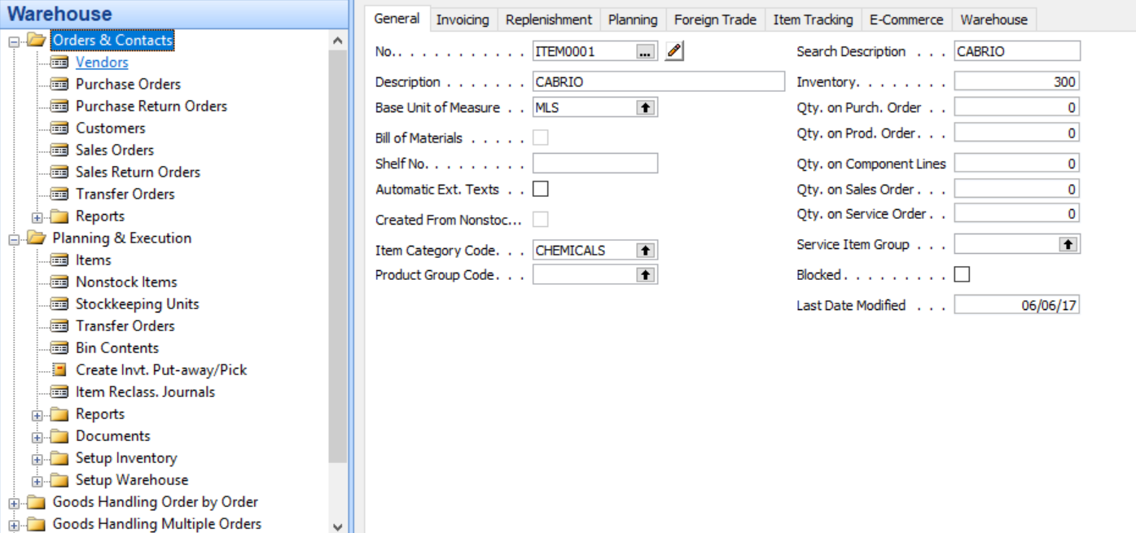

## Security

### Web services

Data from collection devices is sent to the server on real time, this data is sent through secure web services (Apis)

### Encryption

All data transmitted to the server is encrypted making it secure.

### Passwords

All users are required to login to the system.

### User rights

each user has defined rights for access to the system.

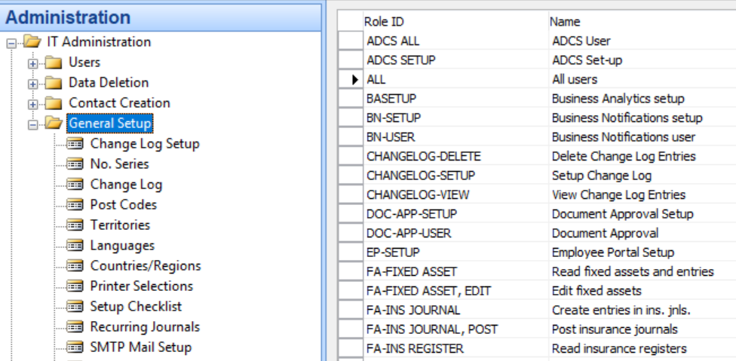

## Pricing

Pricing differs with the no of modules and users that login to the system.

## Project Plan

The whole project implementation estimates is 2-6 months.